Deliveryof Sprint–4

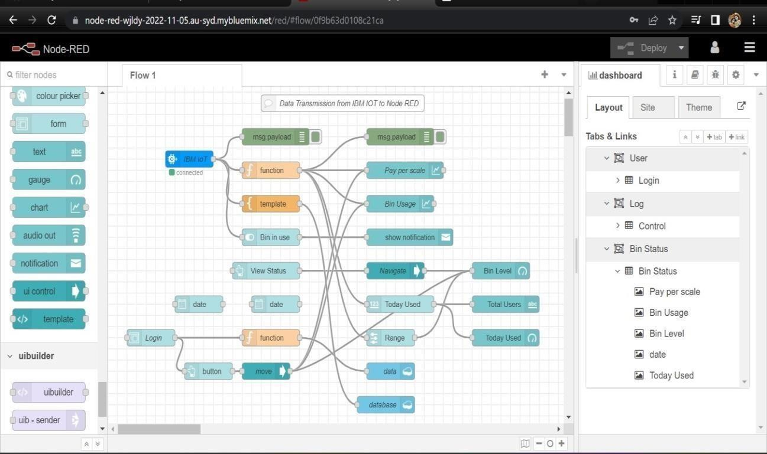

Web UI Design andDeploy

|  |  |
| --- | --- |
| Date | 22November 2022 |
| TeamID | PNT2022TMID06240 |
| ProjectName | Smart Waste Management for Metropolitan citiesCities -IOT |

1. Node-RED Connectionsetupfordata transmissionfromIBMWatsonIOTplatformto Node-REDdashboard.

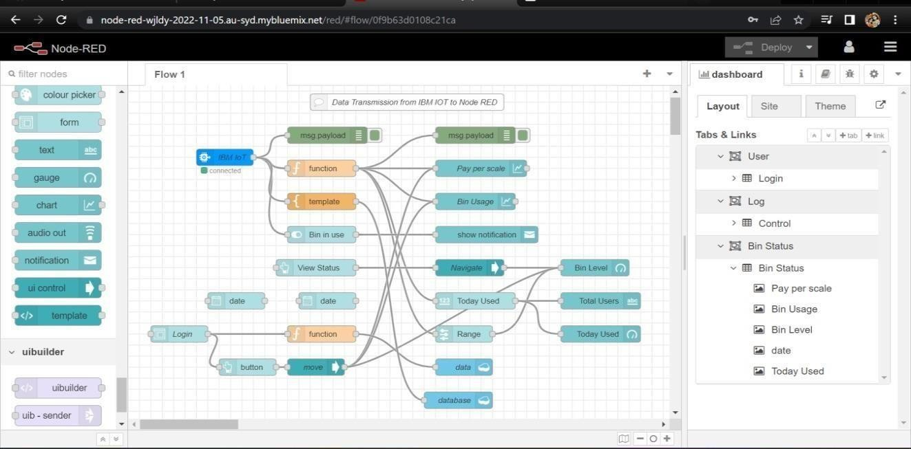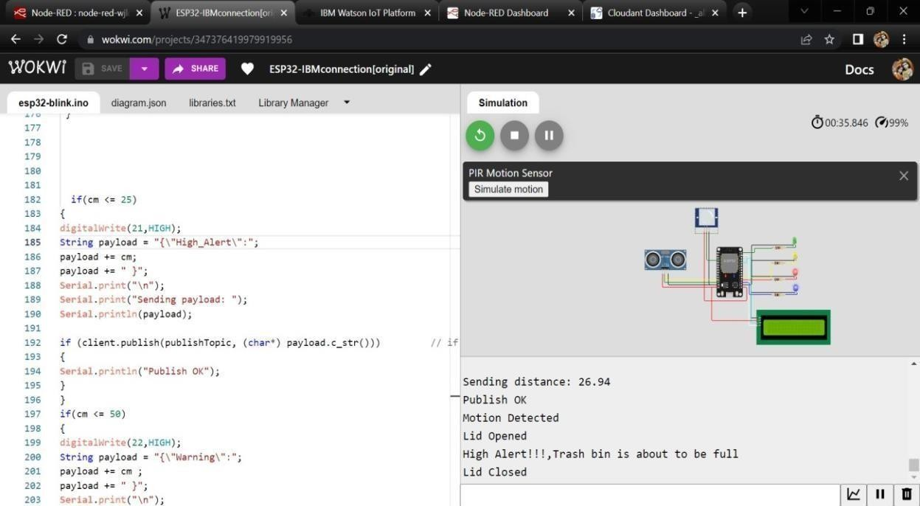

1. SimulateWokwi connectionto transmitdatafromwokwiaccountto IBMWatsonIOTplatformand thentoNodeReddashboard.
2. DatatransfertoWatsonIOTplatform.

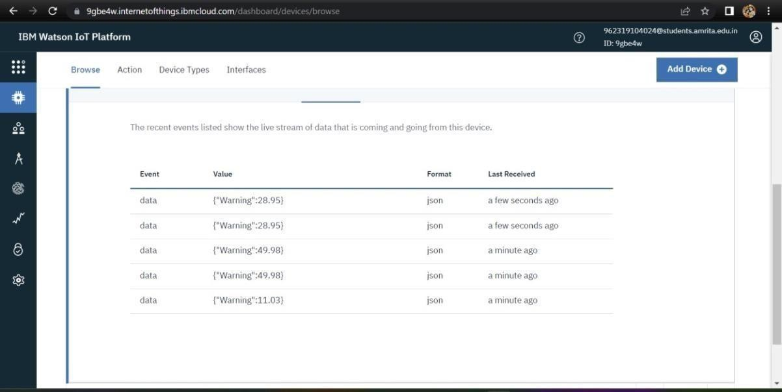

1. Data transfer fromIBMWatsonIOTplatformandwokwito Nodered.

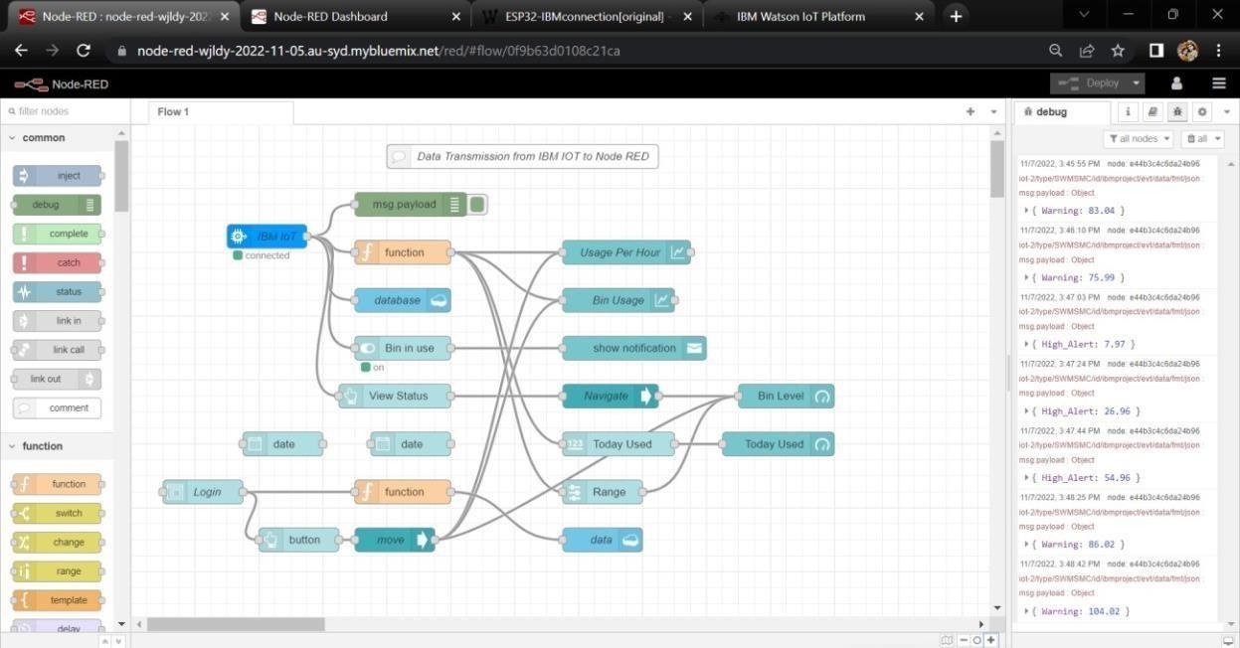

5.StoringdatabaseinIBMcloudantDB.

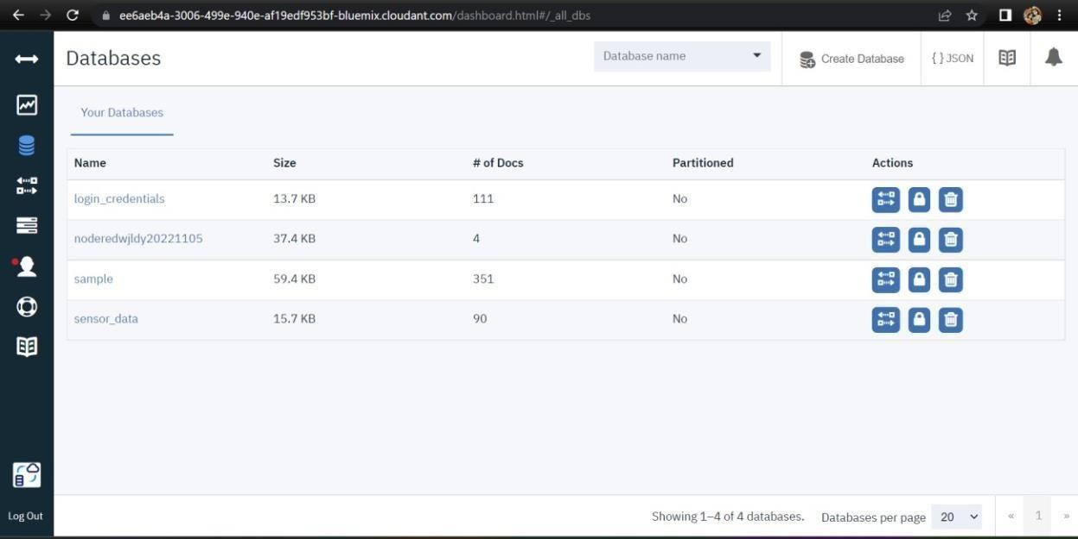

6.Dataisstored inJSONformat

